NMRS installation using Docker on Ubuntu 24.04 LTS
Introduction
Docker is a platform that allows you to develop, deploy, and run applications within lightweight, isolated containers. Containers are a form of virtualization that packages an application and its dependences together in a consistent and portable unit. This enables you to create, test, and deploy applications in a consistent environment across different systems and environments, such as development, testing, and production. NMRS installation using docker also allows the sharing of one modules folder across the NMRS containers.
Requirements for a single instance of NMRS.
- A computer with Ubuntu 24.04 LTS operating system (Tested on Core i7).
- NMRS custom modules.
- NMRS docker installation script (.sh)
- docker-compose.yml file.
- Internet connection.
Procedures
- Download the required files from the repository.
- Extract the zipped installation folder on your desktop location and name it nmrs_docker_ubuntu (please use lower case)
- The directory structure should look like this:
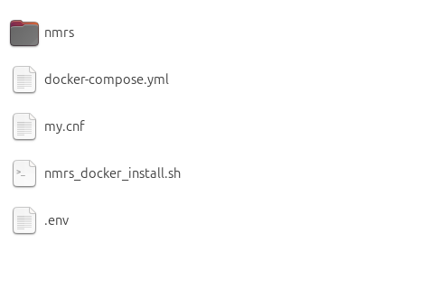
- The nmrs folder will map to the openmrs root directory in the container for easy module deployment, runtime properties file edit, etc)
- Important: Edit your credentials in the .env (You can create one if it is not available).
- Make desired changes to the docker-compose.yml (or just review it to know the basic parameters).
- The my.cnf file is mounted as a volume to enable easy configuration of the mysql server. (innodb_log_buffer_size, sql_mode, innodb_buffer_pool_size, etc).

- Right click the .sh file and give it executable permission.
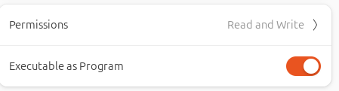
- Execute the script and see notification in the terminal. You may be prompted for credentials user authentication.
- The script includes command to download Docker CLI and related dependences. If successful, you should see an output on the command prompt like the screenshot below:
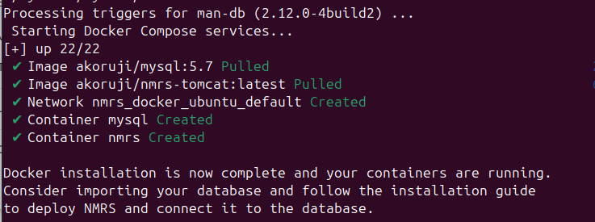
- To check docker status, open terminal and type: sudo docker ps and you will see a list of containers and their ports.
- Use your preferred database management software like Navicat or MySQL workbench to access the database connection using the connection details in the docker-compose.yml
- Create your desired database.
- Import your desired database.
- Open your web browser and type for example this address to deploy the war file: http://localhost:8085/openmrs/initialsetup (you can replace the port: 8085 with your configured external port number for the tomcat container).
- Click the right arrow to proceed.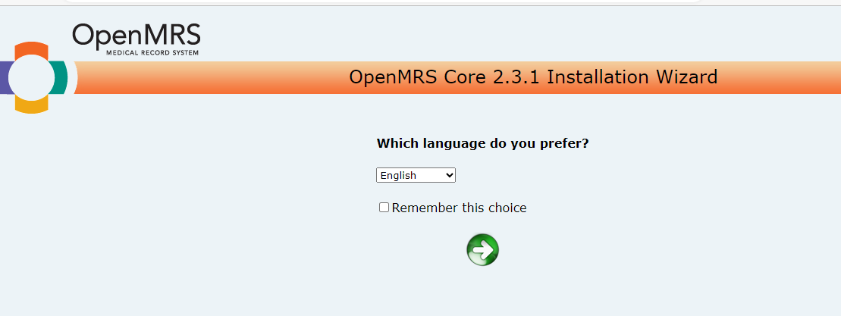

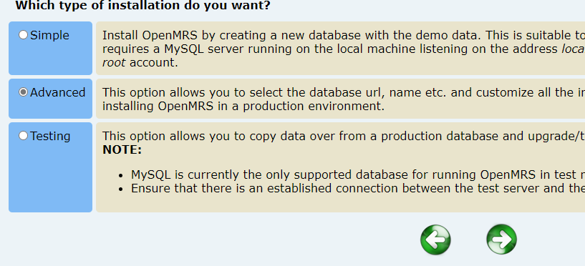
- Click advanced and the right arrow to proceed.

- On the next page, under database connection, change localhost to mysql. This is the mysql service name you created earlier in the docker-compose.yml:
From
To

- If you have imported your database as required in step 14, you should select yes and specify your database name as shown below and click the right arrow to proceed.
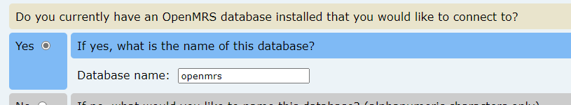

- On the next page, type your database username and password and click the right arrow to proceed.
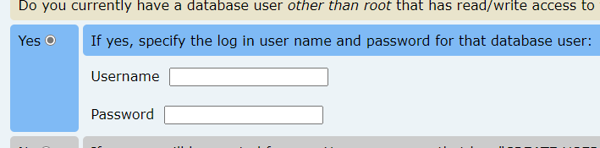

- On the next page, click the right arrow to proceed.
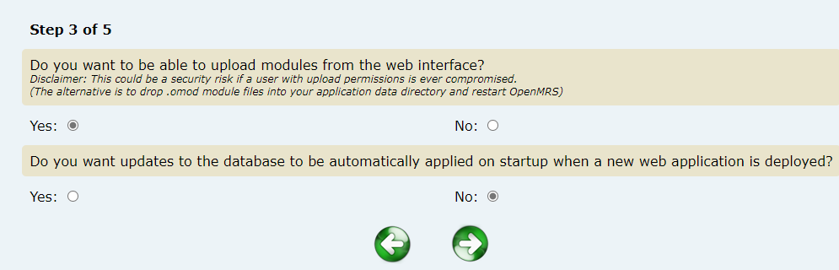

- On the next page, take note of the location of the runtime properties as shown below then click the right arrow to proceed:
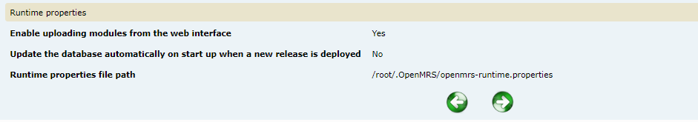
- Wait for the installation to complete
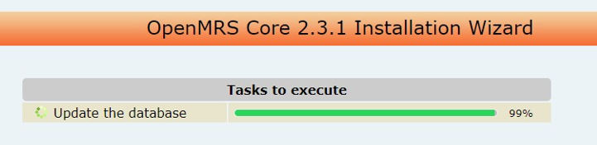
- When it is completed, go to the terminal and restart Docker: sudo systemctl restart docker.

- Go to your browser and refresh the NMRS page and wait for the page to load.
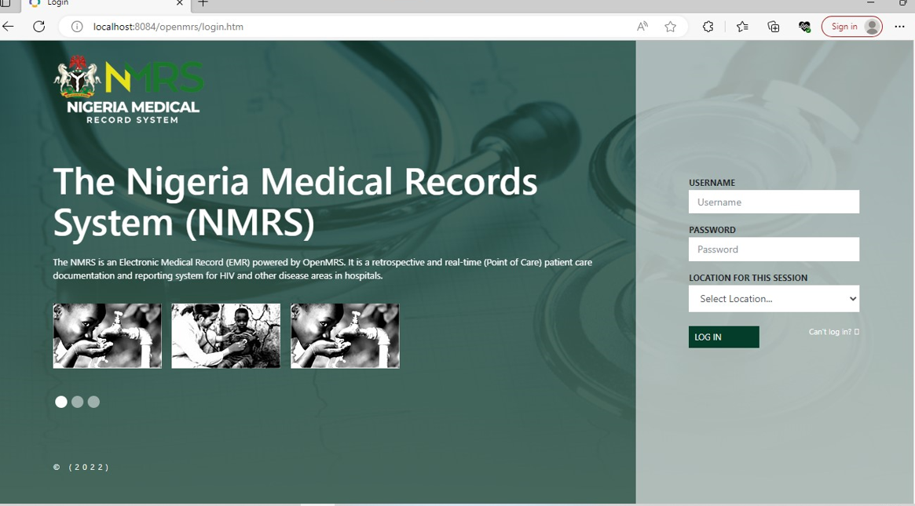

For more information please contact: hi@ihvnigeria.org

